**ELECTRIC TOOTHBRUSH**

An electric toothbrush is a [toothbrush](https://en.wikipedia.org/wiki/Toothbrush) that makes rapid automatic bristle motions, either back-and-forth [oscillation](https://en.wikipedia.org/wiki/Oscillating) or [rotation](https://en.wikipedia.org/wiki/Rotation)-oscillation (where the brush head alternates clockwise and counterclockwise rotation), in order to [clean teeth](https://en.wikipedia.org/wiki/Tooth_brushing).

**Aging and Costing**

|  |  |  |
| --- | --- | --- |
| **YEAR** | **FEATURES** | **COST** |
| 1954-1990 | Conventional Toothbrush | Low Cost |
| 1990-2000 | Automatic Toothbrush with NiCd battery | $13-$15 |
| 2000-2015 | Sonic Toothbrush ,Pocket friendly,lightweight,rotating power head. | 1000-2000/- |
| 2015-2020 | Ultrasonic Toothbrush with magnetic charging,low noise,Led Indicator.Different modes,Timers | 500-5000/- |

**Problem Statement**

Design an electric light weight toothbrush with improved battery life.

**SWOT Analysis**

**Strengths**

Below are the Strengths in the SWOT Analysis of Oral-B:

1. Frequent and many innovations in a low involvement product like toothbrush

2. Introduction of new features regularly

3. Focuses on solving problems commonly associated with toothbrush use

4. Aggressive advertising

**Weaknesses**

1.Price wars with competitors

2.New innovations coming up in the market

3.Indian market not as responsive to innovations in toothbrush as global market

**Opportunities**

1.More innovations to differentiate from the competitors

2.Increasing involvement in personal care products

3.Differentiated advertising methods to attract customers

**Threats**

The threats in the SWOT Analysis of Oral-B are as mentioned:

1.Aggressive competition

2.Regular introduction of new products by competitors

3.Copied innovation by competitors

Low Level Requirements

* High charging capacity
* Low cost sensors
* Different modes of operation

High Level Requirements

* Safety
* Ease of Portability
* Low cost

**Design**

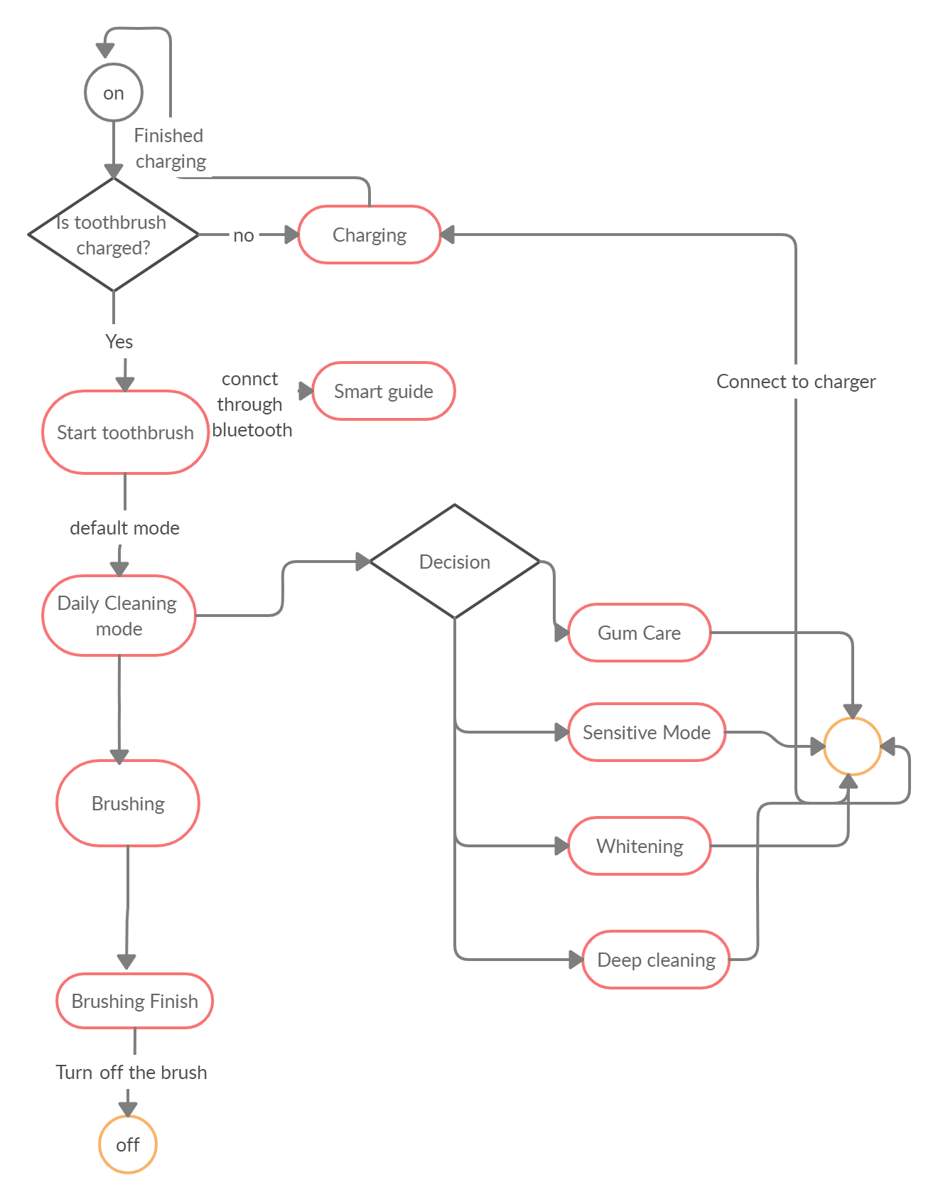

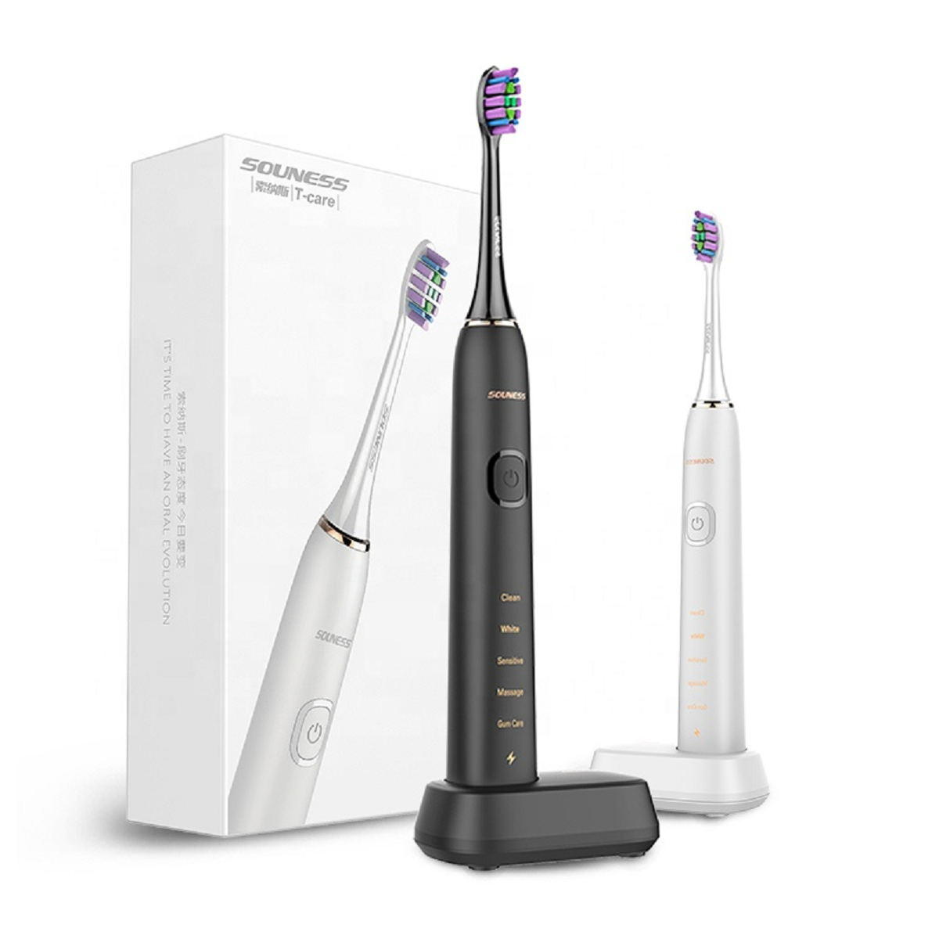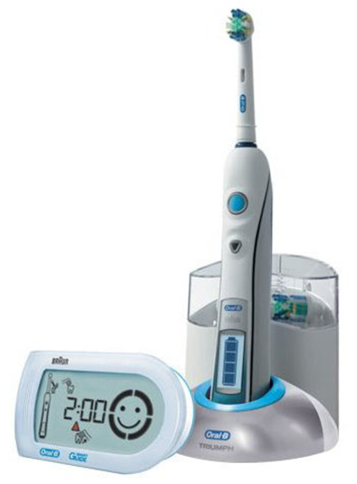

**Test Plan**

**Requirement Based**

* Will the electric toothbrush be quiet and feel nice to brush with?
* Will the electric toothbrush recharge quickly?
* Is it affordable
* Efficiency in cleaning
* Ease to use

**Scenario Based**

* Wounds in mouth
* Power shutdown for longer period

**Boundary Condition**

* Modes are not changing.
* Toothbrush motor failure.
* Difficulty in recharging